Insights into Graphing Calculator Use: Methods for Capturing Activity and Affect

By Allison McCulloch

North Carolina State University, 502L Poe Hall, 2310 Stinson Drive, Raleigh, NC 27695-7801
allison_mcculloch@ncsu.edu

Received: 11 February 2008 Revised: 8 August 2008

There has been much research on the impact of graphing calculator use on mathematics achievement as well as their integration into various mathematics curricula. Recently researchers have begun to try to understand how and why students are using graphing calculators in independent problem solving situations. Collecting data on spontaneous calculator use and its implications has proven to be a challenge in itself. Furthermore, research on the affective domain and its role in problem solving has traditionally been difficult due to a lack of appropriate data collection and analysis methods. The purpose of this paper is to describe a data collection method that has proven effective in capturing data on how and why individual students choose to use graphing calculators outside of whole class situations. This includes methods for capturing video of the graphing calculator screen as well as techniques for using this video for in-depth student interviews. Examples from a study on the actions and affect of students using graphing calculators in problem solving will be used to illustrate these methods.

1 INTRODUCTION

How are students actually using their graphing calculators to support their mathematical learning outside of whole class situations? What do they attend to in the calculator output that is created? What influence does affect have on the decisions they make with respect to graphing calculator use? One of the greatest challenges that researchers interested in questions such as these face is how to collect data that accurately depicts what students are doing with their calculators and why. This paper aims to provide a detailed description of the equipment and a methodology for capturing video of graphing calculator screens in real time. This methodology also provides students the opportunity to reflect on the role of the calculator in their problem solving process. An example from a current study on students’ perceptions of graphing calculator use will be used to illustrate the strengths and weaknesses of this methodology (McCulloch, in progress). For the purpose of this paper, when I refer to a graphing calculator I am referring to graphing calculators both with and without Computer Algebra Systems (CAS) capabilities.

2 LITERATURE

Until recently most of the research on graphing calculator use in mathematics education has either been quantitative in nature focusing on student achievement and attitude or qualitative studies on the teaching and learning of a particular mathematical topic (for example, Choi-Koh, 2003; Ellington, 2003; Forester and Mueller, 2002; Smith and Shotsberger, 1997). There is a growing body of research on how students are adapting graphing calculator technology to their problem solving strategies (for example, Berry and Graham, 2005; Harskamp, Suhre and van Streun, 2000). In addition, recently researchers have been studying how students come to fully integrate graphing calculators as a tool for learning, the theory of instrumentation. Most of these studies have looked specifically at graphing calculators with CAS capabilities. They have found that using graphing calculators with CAS capabilities effectively is not easily learned and that students go through many phases before becoming proficient users (Artigue, 2002; Drijvers, 2000; Guinn and Trouche, 1999). As we learn more about the effects that the adoption of graphing calculator technology seems to be having on the assessment, attitude, and learning of particular topics it becomes apparent that we need to know more about what students are actually doing with their calculators when they work independently, what aspects of the calculator output they attend to, and the role of emotions, values and beliefs in their calculator activity decisions.

One of the greatest challenges of research on graphing calculator use is the ability to capture data from the calculator itself. Researchers have tried methods such as observation, student reports of use, and videotaping the calculator output projected on a screen (for example, Doerr and Zangor, 2000; Drijvers, 2000; Guinn and Trouche, 1999). Observations are sometimes ineffective because it can be disturbing to the student to have someone looking at their calculator screen as they work. On the other hand, asking students to report their graphing calculator work may produce incomplete reports (Ericsson and Simon, 1993). In response to researchers’ needs, Texas Instruments has produced a software product called the Key Recorder that runs in the background of the graphing calculator and collects data on all of the user’s key strokes. This powerful tool has been found helpful to many researchers (for example, Berry and Graham, 2005; Sheryn, 2006). However this software is not appropriate when attempting to link work on the graphing calculator to written work in real time. Furthermore, none of these data collection methods capture the emotions, values, or beliefs related to graphing calculator use. In response to this need a methodology has been developed in which both written and graphing calculator work is recorded and students are given an opportunity to reflect on the work they have done.

3 THEORETICAL FRAMEWORK

A number of graphing calculator studies have suggested that having a calculator available might improve students’ problem solving performance simply because they feel more comfortable (Dunham, 2000; Ellington, 2000). In order to address this suggestion and attend to why students choose to use their graphing calculators in independent problem solving situations it is necessary to focus on the affective domain.
The affective domain refers to the internal system that includes emotions, attitudes, beliefs, morals, values, and ethics (DeBellis and Goldin, 1997). This system is representational, meaning that it exchanges information with cognitive systems. The methodology to be presented here is grounded in DeBellis and Goldin’s (2006) research-based theoretical framework on affect as a representational system (see Figure 1). DeBellis and Goldin describe two categories of affect, local affect and global affect. Local affect refers to changing states of feeling during problem solving. Global affect refers to more stable, longer-term affective constructs such as attitudes, values, and beliefs. Over time local affective experiences that are similar and powerful can come to influence the more stable constructs of global affect. For example, if a student has repeated experiences of frustration when trying to create and use a table on a graphing calculator to solve a problem, that student may start to have a negative attitude toward the table tool and even possibly develop the belief that the table is not a useful tool. In addition, an individual’s affect is also influenced by the affect of others, social and cultural conditions and external contextual factors. For example, a student that repeatedly hears from a teacher that the graphing calculator should only be used as a last resort when problem solving may possibly feel guilty when the decision is made to use one.

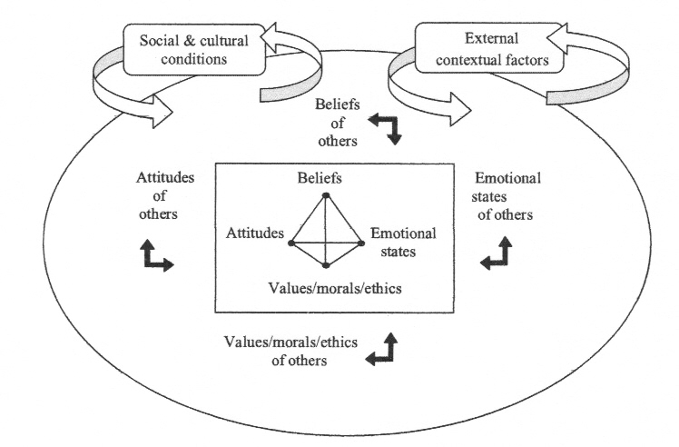

Figure 1 DeBellis and Goldin’s (2006) framework for affect as a representational system

Goldin (2000) has pointed out that students use emotions to provide useful information, to facilitate monitoring and to evoke heuristic processes. He suggests that affect is not inessential, but critical to the structure of competencies that account for success or failure in problem solving. To better understand the role of local affect in problem solving Goldin introduced the notion of affective pathways. Affective pathways are sequences of states of feeling that interact with cognitive representations in problem solving. An example of an affective pathway follows:

In an (idealised) model, the initial feelings are of curiosity. If the problem has significant depth for the solver, a sense of puzzlement will follow, as it proves impossible to satisfy the curiosity quickly. Puzzlement does not in itself have unpleasant overtones – but bewilderment, the next state in the sequence, may. The latter can include disorientation, a sense of having “lost the thread of the argument” of being “at sea” in the problem. If independent problem solving continues, a lack of perceived progress may result in frustration, where the negative affect becomes more powerful and more intrusive. This is associated with the occurrence of an impasse. However, there is still the possibility that a new approach will move the solver back to the sequence of predominately positive affect. Encouragement can be followed by pleasure as the problem begins to yield, by elation as major insights occur, and by satisfaction with the sense of a problem well solved and with learning that has occurred (Goldin 2000, p. 211).

This idealised model illustrates how local affect might influence the heuristics employed by a problem solver. In the context of this paper the focus is on how the availability of a tool like the graphing calculator might further influence an affective pathway like the one described above. For example, if a student is facing feelings of bewilderment or disorientation it is possible that the introduction of a useful tool might invoke feelings that are of a more positive sequence.

At this point, graphing calculator studies have addressed the more stable affective notion of attitude, but few, if any, have addressed local affect. This is likely due to the difficulty in designing and carrying out reliable empirical studies on affect (DeBellis and Goldin, 2006). The methodology described here aims to attend to these design difficulties in research on affect and graphing calculator use in problem solving. The following sections will describe in detail the equipment and process involved and then an example from a current study on students’ perceptions of graphing calculator use will be used to illustrate the strengths and weaknesses of this methodology.

4 RESEARCH DESIGN

For research that aims to describe problem solving strategies and decision making in detail a structured task-based interview is typically an appropriate design choice (Goldin, 2000). According to Goldin (2000), a structured task-based interview is one in which a problem solver and an interviewer interact in relation to a set of tasks introduced to the problem solver in a pre-planned way. He points out that often a “think out loud” protocol is followed with hopes to reveal the thoughts behind the written work. However, when the purpose is also to attend to emotions and values related to these strategies and decisions a “think aloud” protocol is unsuitable. The repeated asking of self-monitoring questions, like those related strategy and emotion, is likely to affect the problem solving process (Goldin, 2000).

In order to address the need to ask questions about strategy and emotion without influencing the problem solving process a video stimulated response (video-SR) design was used in conjunction with the task-based interview. Video-SR is a procedure in which videotaped behavior is replayed to an individual to stimulate recall of their activity (Lyle, 2003). In this case the purpose is to stimulate the recall of both cognitive and affective activity. Lyle (2003) suggests that video-SR is appropriate for studies that “benefit from minimal intervention in the activity” (p.862). As pointed out above, the challenge here is to capture all activity. In a design using a task-based interview in which the graphing calculator is available that means that written work, gestures, facial expressions, and graphing calculator work must all be captured on video. Furthermore, the video must be compiled in such a way that the problem solver can view it all in real-time, meaning exactly as it took place, in order to stimulate recall. The suggested equipment and process for constructing the video for a video-SR of this nature is described below.

5 EQUIPMENT AND PROCESS

In order to capture video of the graphing calculator screen the TI Presenter is used. The TI Presenter is a USB video capture card and video editing software made by Texas Instruments. The TI Presenter video interface is designed to allow any TI calculator to connect to the video input of a conventional TV, VCR, or projector. Using a USB video capture card, such as the Pinnacle Dazzle, the TI Presenter video interface can be fed directly into the video editing software of any PC. Using RCA cables the TI Presenter is connected to the USB video capture card, which in turn is connected to the PC. Once all connections are complete, video editing software will recognise the USB video capture card as an input device. Finally, begin a video capture when the graphing calculator is in use.

When conducting task-based interviews, students are provided with the graphing calculator that they use regularly, for example the TI-83+ or the TI-89. A standard video camera on a tripod is used to capture students as they work. It is important that this camera picks up the students gestures when the graphing calculator is being used as well as capture the student’s written work. At the same time the TI Presenter and video editing software is capturing all of the graphing calculator work.

The final step is to put these two pieces of video together side-by-side on a single PowerPoint slide. When running the slideshow both videos can be activated and thus providing a real time recreation of the written and calculator work. This side-by-side video slide is then shown to students. As students view the video slide, they are asked to recall their work using the video as a stimulus. When the student was seen using the graphing calculator they were asked questions like, “Why did you decide to use your graphing calculator?” and “How did the (screen produced) help you?” When the student was seen making emotive gestures, like slumping down with a hand on the forehead they were asked “What were you feeling right there?” This type of video-SR interview along with the video itself provides detailed data related to graphing calculator activity, decisions behind graphing calculator use, what was attended to on the graphing calculator screen, how the graphing calculator helped or hindered the problem solving process, and the emotions that accompanied its use. Together this data can be used to reconstruct problem solving methods and reported affective pathways for each task.

6 AN EXAMPLE

The following example is taken from a study designed to investigate students’ perceptions on how the graphing calculator impacts on their problem solving strategies when they are working independently (McCulloch, in progress). The students in this study participated in a video- SR task-based interview using the methodology described above.

Maryanne, a high school calculus student, was given a series of tasks to solve including the following:

Find the maximum rate of change of the graph of

Maryanne’s written work appears in Figure 2. She worked uninterrupted while both her written work and calculator screen where captured on video as described above. From her written work we can see that she was close to a complete solution. However, we cannot determine the order in which she did the written work along with any calculator work, what aspects of the graphing calculator output she attended to, or any information about the decisions she made regarding use of the graphing calculator. Watching the video of Maryanne’s written work and calculator work side-by-side in real time allows for a complete reconstruction of her actions from the viewpoint of an observer. A reconstruction of this work appears below.

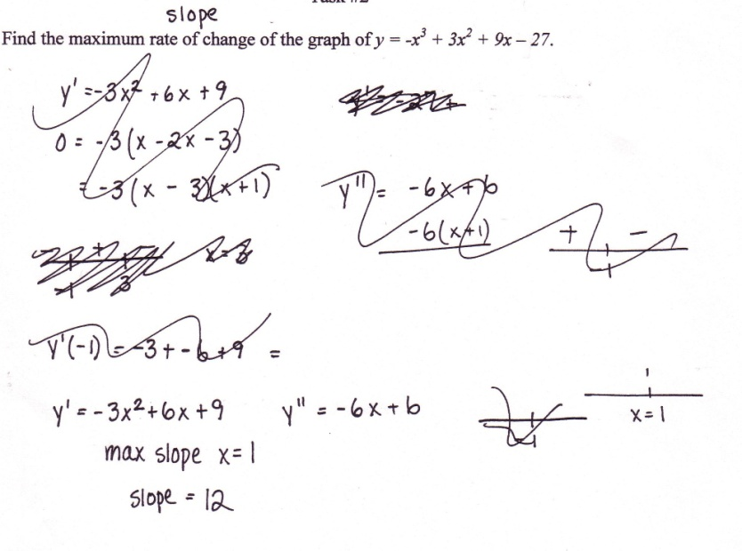
Figure 2 Maryanne’s written work

Maryanne began this task by working on paper. She first wrote down and then crossed it out. Next she wrote the first derivative, set it equal to zero, and factored it (incorrectly). Directly below she sketched a number line on which she denoted and and the sign of all values on either side of these points. She looked at this for a moment and then crossed out the number line. Next she wrote down the second derivative and a second number line denoting She then began to evaluate the first derivative at $−1$, looked at it for awhile, and then left it and went to work on another task.

When Maryanne returned to the task she immediately crossed out her previous work. She re-read the problem, and above the phrase ‘rate of change’ she wrote ‘slope’, then began to write again. She wrote the first and second derivative and another number line with denoted on it. Then she picked up her graphing calculator, a TI-83+, and graphed the original function . After changing the window using the zoom standard command she looks at the graph for a moment. Next she returns to the y= screen and inserts nderiv in front of the original function she had entered, changes her mind and instead enters nderiv(y1, x, x) in y2 which commands the calculator to sketch the graph of the original function, y1, and the first derivative of y1 on the same screen. After looking at the graph of both functions together, she zooms out so that she can see the functions in a larger window. She follows this inspection of the graph with the use of the max tool on the calculator to find the maximum of y2, the derivative. The calculator determines the maximum to be 12 at x = 1. Maryanne considers this for awhile, returns to her written work where she crosses out the number line she had drawn with x = $−1$. She writes down her solution, maximum slope at x = 1 is 12. Finally, she finishes by sketching a number line one more time with x = 1 denoted.

Upon completion of the reconstruction of Maryanne’s work we have a much better picture of what actions actually lead to her solution. However, we still do not know much about the role of the graphing calculator. We do know when she used it in relation to her written work and what she produced on it, but we do not know how this information was interpreted and then used, nor do we know anything about what drove the decisions she made in this process.

Using the reconstruction above along with the video-SR data it is possible to construct Maryanne’s reported affective pathway for this particular task. By reported affective pathway, I mean the path of emotions/values/attitudes/beliefs that she reports having felt with respect to the activity and decision making she has recalled for this particular task. While Maryanne watched side-by-side videos of herself working on the task and her calculator work she was asked to talk about what she was doing, why she chose to do it, and what these actions afforded her. For example, we know she picked up her calculator and used it to graph both the original function and its derivative. When she watched herself look at the graph she recalled, “Well, I knew that the slope is clearly the steepest in this area (see Figure 3) so I could tell that to begin with… I found the maximum of the slope just using the maximum function. Then I looked back and it said it was at one and I was like that’s where I made my simple algebra mistake!”

Thus, we know now that Maryanne perceived that the graph she produced on the calculator along with the solution she produced using the maximum function not only provided her with an answer, but also helped her identify her mistake.

Maryanne, unprompted, also reported how she felt at different points in this process. For example, as she watched herself cross out her written work she said, “So, um, I was just really confused on the first part, so I crossed it out and decided to start over.” As she watched herself pick up the graphing calculator she groaned. I asked her why she made that noise and she said that she didn’t like to rely on her calculator, she felt guilty when she had to use it. However, she also said that she was relieved when she recognised her error, “Whew, I knew that wasn’t right, (smiles) but I knew I knew what I was doing.” Maryanne went on to talk about how she feels about being able to use the graphing calculator in situations like this. She said, “I’m a visual person and it bothers me sometimes that I can’t always see it in my mind. So I do like to be able to see it at some point. It’s just a lot easier to know what you’re dealing with instead of just having a bunch of numbers…it’s happened before where you see the graph and realise there’s something wrong in my work. I should go back and look at it.” Maryanne’s complete reported affective pathway for this task appears in Figure 4.

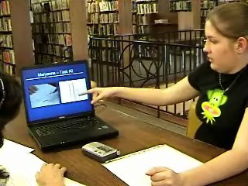 | 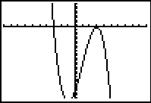
Figure 3 Maryanne pointing to the graph (shown on the right) during her stimulated response interview.

Activity | Reported Associated Affect
First derivative and zeros on paper

Second derivative and zero (incorrect) on paper

Evaluated first derivative at -1 and found  equal to 0 | Confusion
Graphed functions on GC | Comfort and Guilt
Recognised error | Relief
Found and recorded solution | Happiness
Figure 4 Maryanne’s reported affective pathway

7 LIMITATIONS

Though this methodology has definite benefits for researchers who aim to look closely at graphing calculator activity and the associated affect, it certainly has limitations. Using the equipment as described above, data can only be collected from one student at a time, thus it is not an appropriate methodology for large groups. In addition, the quality of data is dependent in large part on the student’s willingness to talk freely about the problem solving process. However, Maryanne, the example provided above, is representative of all of the students with which this design has been used.

Another drawback is that the emotions that are revealed during the video-SR interview are not necessarily the same as the emotions actually felt in the moment that the event took place. However, the emotions are what the student remembers feeling in the moment, so in a sense they may be even more important. The emotions that are reported during the video-SR interview are those that the student recalls feeling and therefore are those that the student will associate with that event in the future. The feelings that students associate with particular activities are more likely to have an impact on future problem solving decisions. In addition, the feelings that students associate with events and decisions are likely to impact the more stable affective structures like values, attitudes and beliefs.

8 CONCLUSION

Though this methodology may be time consuming and expensive to use with large groups of students, it has proven to be very effective for use in research designed to capture data from individual students. The use of real time video of both written work and calculator work followed by a video-SR interview provides information on students’ graphing calculator use that was previously unavailable. Maryanne’s work and interview suggest that the availability of the graphing calculator provides students with more than just solutions. The methodology described in this paper provides students with the opportunity to reflect on the multifaceted role of the calculator in their problem solving process.

ACKNOWLEDGEMENTS

I would like to thank Maryanne, who so generously offered her time to participate in this study.

REFERENCES

Artigue, M. (2002) Learning mathematics in a CAS environment: The genesis of a reflection about instrumentation and the dialectics between technical and conceptual work, International Journal of Computers for Mathematical Learning, 7, 245-274.

Berry, J. and Graham, T. (2005) On high-school students’ use of graphic calculators in mathematics, ZDM-The International Journal on Mathematics Education, 37(3), 140-148.

Choi-Koh, S. (2003) Effect of a graphing calculator on a 10th grade students’ study of trigonometry, The Journal of Educational Research, 96(6), 359-369.

DeBellis, V. A. and Goldin, G. A. (1997) The affective domain in mathematical problem solving, in Pehkonen, E. (ed.), Proceedings of the Twenty-First Annual Meeting of PME, Lahti, Finland: PME.

DeBellis, V. A. and Goldin, G. A. (2006) Affect and meta-affect in mathematical problem solving: A representational perspective, Educational Studies in Mathematics, 63, 131-147.

Doerr, H. M. and Zangor, R. (2000) Creating meaning for and with the graphing calculator, Educational Studies in Mathematics, 41, 143-163.

Drijvers, P. (2000) Students encountering obstacles using a CAS, International Journal of Computers for Mathematical Learning, 5, 189-209.

Dunham, P. H. (2000) Hand-held calculators in mathematics education: A research perspective, in Laughbaum, E. (ed.), Hand – Held Technology in Mathematics and Science Education: A Collection of Papers, Columbus, OH: The Ohio State University, 39-47.

Ellington, A. (2003) A meta-analysis of the effects of calculators on students’ achievement and attitude levels in precollege mathematics classes, Journal for Research in Mathematics Education, 34(5), 433-463.

Ericsson, K. A. and Simon, H. A. (1993) Protocol analysis: Verbal reports as data, Cambridge, MA: MIT Press.

Forester, P. A., and Mueller, U. (2002) What effect does the introduction of graphics calculators have on the performance of boys and girls in assessment in tertiary entrance calculus?. International Journal of Mathematical Education in Science and Technology, 33(6), 801-818.

Goldin, G. A. (2000a) Affective pathways and representation in mathematical problem solving, Mathematical Thinking and Learning, 2, 209-219.
Goldin, G. A. (2000b) A scientific perspective on structured, task-based interviews in mathematics education research, in Kelly, A. E. and Lesh, R. A. (eds..), Research Design in Mathematics and Science Education, Mahwah, NJ: Lawrence Erlbaum Associates.

Guinn, D. and Trouche, L. (1999) The complex process of converting tools into mathematical instruments: the case of calculators. International Journal of Computers for Mathematical Learning, 3, 195-227.

Harskamp, E. G., Suhre, C. J. M. and van Streun, A. (2000) The graphics calculators and students’ solution strategies. Mathematics Education Research Journal, 12(1), 37-52.

Lyle, J. (2003) Stimulated recall: A report on its use in naturalistic research, British Educational Research Journal, 29(6), 861-878.

McCulloch, A. W. (in progress) Calculus students’ perspectives on graphing calculator use: Attending to mathematical and affective experiences.

Sheryn, L. (2006) What do students do with personal technology and how do we know? How one student uses her graphical calculator, International Journal of Technology in Mathematics Education, 13(3), 1-8.

Smith, K. B. and Shotsberger, P.G. (1997) Assessing the use of graphing calculators in college algebra: reflecting on dimensions of teaching and learning. School Science and Mathematics, 97(7), 368-377.

BIOGRAPHICAL NOTES

Dr. Allison McCulloch is an Assistant Professor of Mathematics Education at North Carolina State University in Raleigh, North Carolina. Her current research is focused on understanding both the mathematical and affective impact of technological tools on students’ problem solving experiences and the influence the use of these tools has on their perceptions of mathematics.

